PRACTICAL ASSIGNMENT

Class:BCA Ai/ml

Name:Astitva Sharma

Group1:

Q1:Create a simple html page using basic tags.

<html>

<HEAD>

<title>My world</title>

</head>

</html>

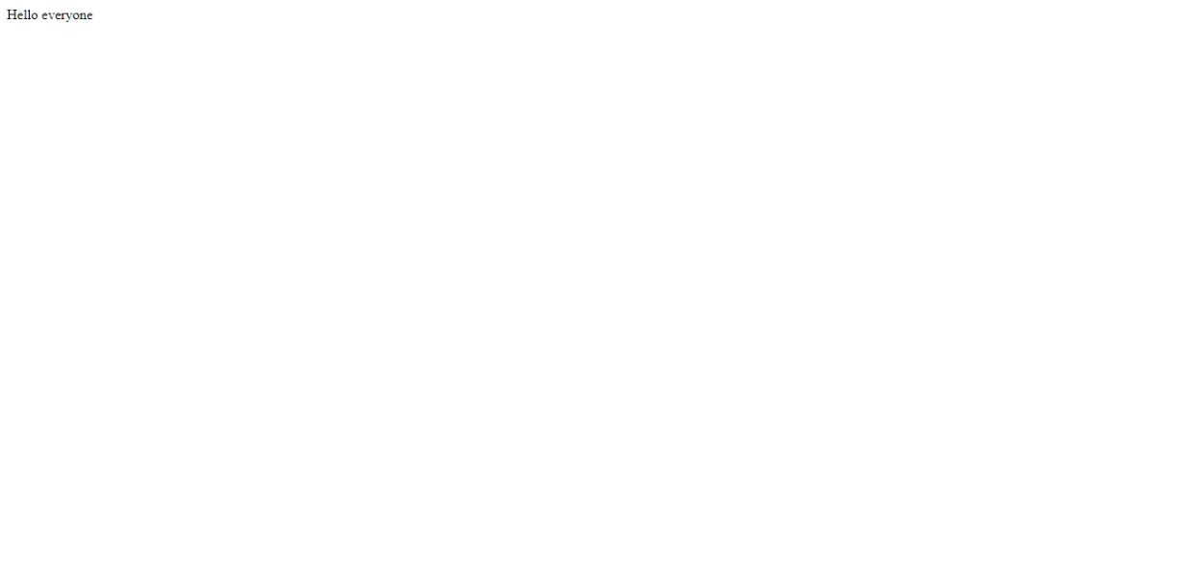

Q2 Create a web page that displays ur name to the screen.

<html>

<HEAD>

<title>My World</title>

<body>Astitva Sharma</body>

</head>

</html>

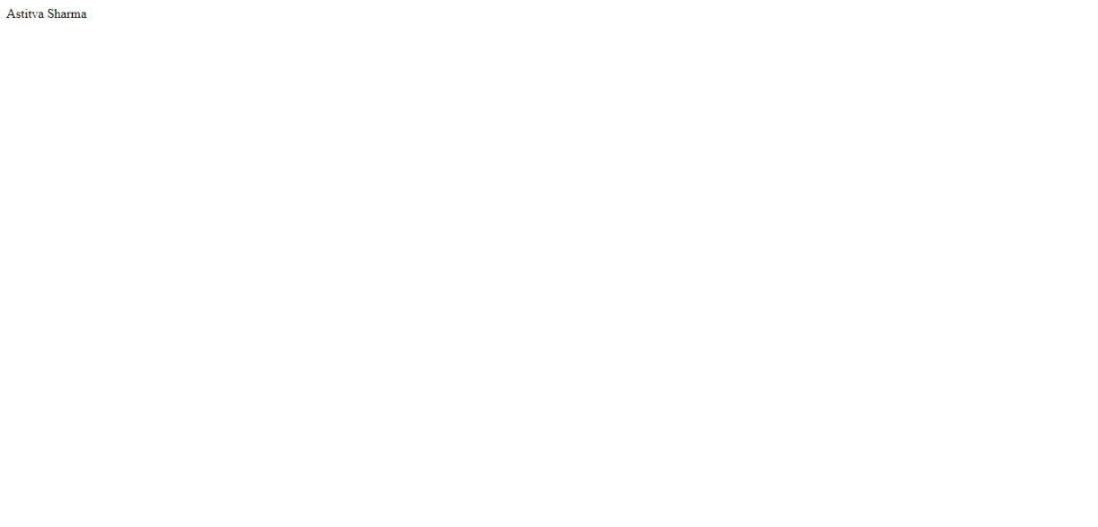

Q3.Create a web page and show the output from 1 to 10 in separate lines.

<html>

<HEAD>

<title>My World</title>

<body>

1<br>2<br>3<br>4<br>5<br>6<br>7<br>8<br>9<br>10<br>

</body>

</head>

</html>



Q4 Create a web page and show the output from 1 to 10 in separate lines,each number being in different colour.

<html>

<HEAD>

<title>My World</title>

<body>

<font color="black">1 </font><br>

<font color="red">2</font><br>

<font color="blue">3</font><br>

<font color="green">4</font><br>

<font color="yellow">5</font><br>

<font color="gray">6</font><br>

<font color="pink">7</font><br>

<font color="purple">8</font><br>

<font color="white">9</font><br>

<font color="brown">10</font><br>



Q4 How do I make a picture as a background on my web pages?

<html>

<HEAD>

<title>My World</title>

<body>

<body background="C:\Users\student\Desktop/jon.jfif">

</body>

</head>

</html>



Q6 Create a web page to print a paragraph with 4-5 sentences,each sentence shall have a different font.

<html>

<HEAD>

<title>My World</title>

<body>

<B>My name is Astitva Sharma</B><br>

<I> am cureently pursuing Bca in specialisation of AI/ML in Manav Rachna Institute of Research and Studies.</I><br>

<u>I live in faridabad.</u><br>

<p>My hobbies are playing video games and swimming.In future I want to work in a big MNC like google or microsoft which is why I am pursuing BCA.</p><br>

<em>I live in a nuclear family, i live with my mom and dad.I have no siblings.Currently , i have been just introduced with C language and Html

and it is really interesting.</em><br>

</body>

</head>

</html>

) W 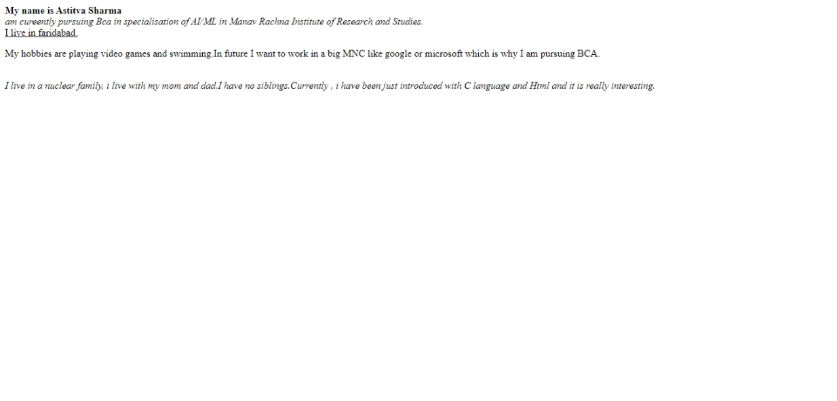

Q7)Write HTML code to print a paragraph that is description of a book, it shall include the title of the book, its author name; name and title should be underlined and all adjectives shall be bold and Italics.

<html>

<head>

<title> Story book</title>

<H1><u><b>Five on a treasure island</b></u></H1>

<p><i> Author Name: Eileen Soper <br></i>

<i>Five on a Treasure Island (published in 1942) is a popular children's book by Enid Blyton. It is the first book in The Famous Five series. The first edition of the book was illustrated by Eileen Soper.Famous Five: Part 1: Five on a Treasure Island” by Enid Blyton is the first book in the popular Famous Five series. This thrilling adventure introduces readers to a group of young friends and their quest for hidden treasure on a mysterious island. Enid Blyton, a beloved British children’s author, weaves a tale of excitement, friendship, and discovery that has captivated generations of readers.The story begins with the four cousins — Julian, Dick, Anne, and George — and their dog, Timmy, gathering at Kirrin Cottage for their summer holidays. The cousins have always looked forward to their vacations together, and this time, they are particularly excited because they will be visiting George’s family home on Kirrin Island.</i></p>

</body>

</html>

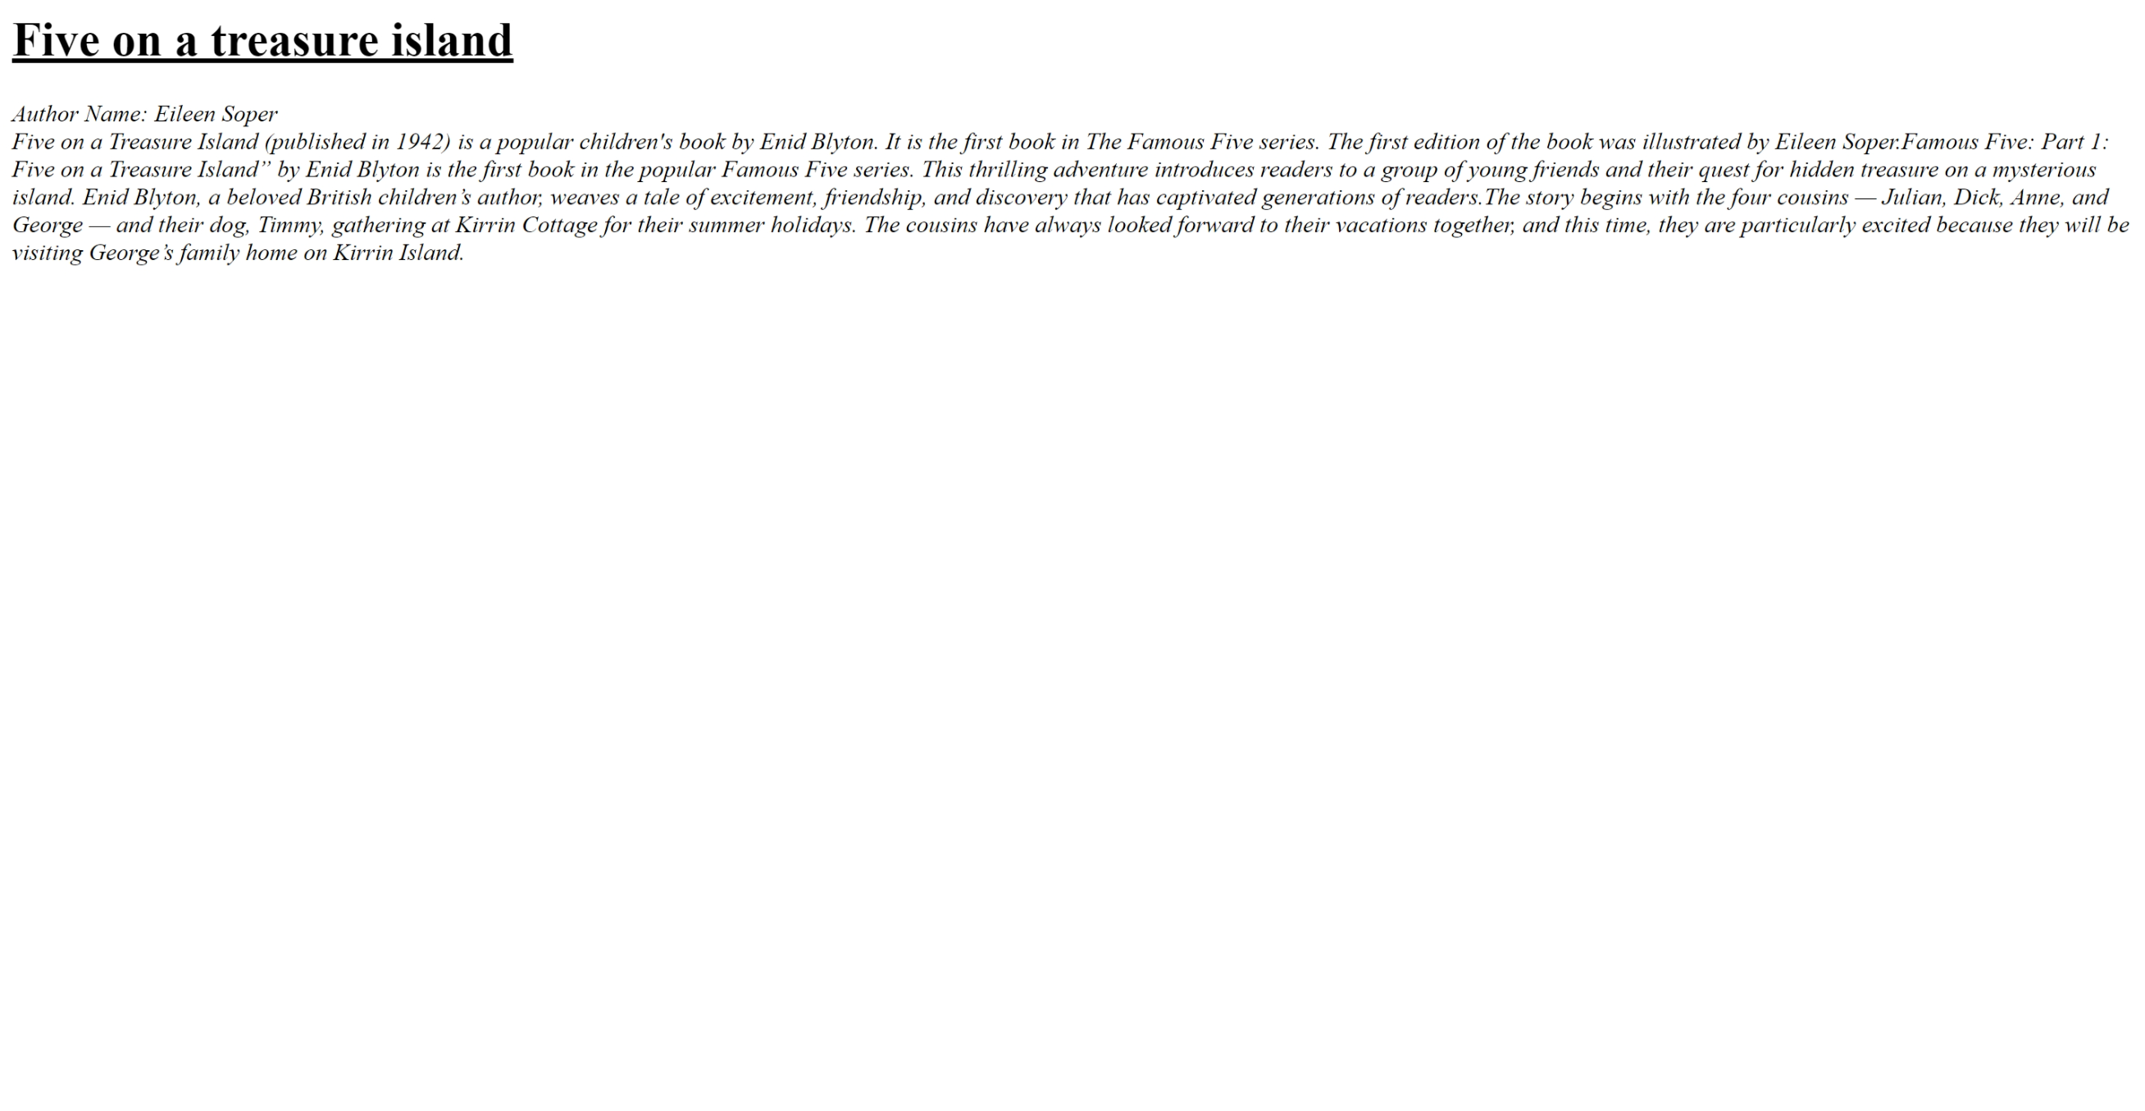

Q8)Write HTML code to print your name using heading tag,every letter shall be of different heading size?

<HTML>

<HEAD>

<TITLE>ASTITVA</TITLE>

</HEAD>

<BODY>

<H1>A</H1>

<H2>S</H2>

<H3>T</H3>

<H4>I</H4>

<H5>T</H5>

<H6>V</H6>

<H1>A</H1>

<H2>S</H2>

<H3>H</H3>

<H4>A</H4>

<H5>R</H5>

<H6>M</H6>

<H1>A</H1>

</BODY>

</HTML>

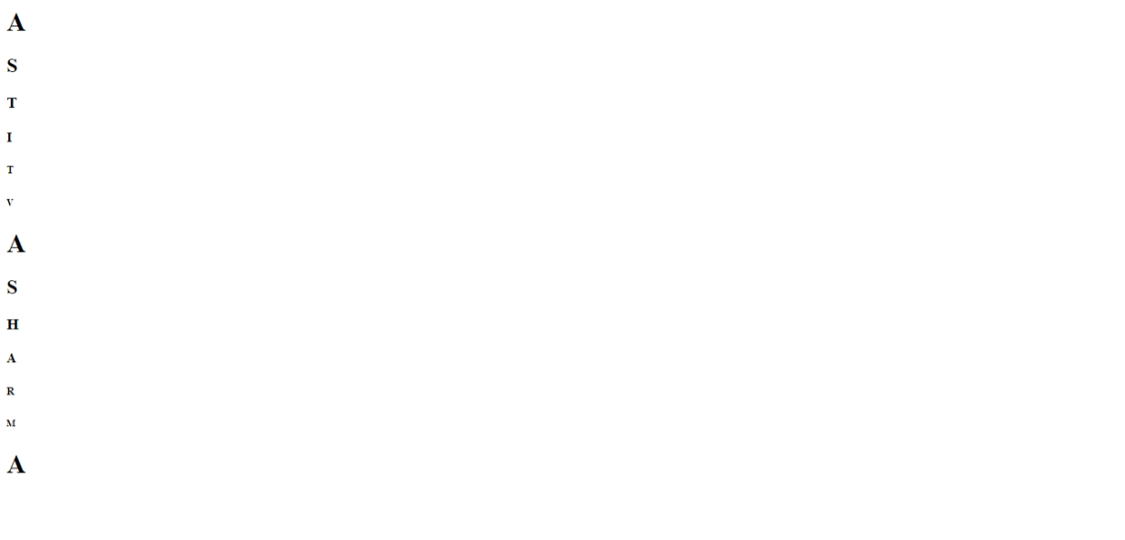

Q9) **Write Html code to print the sequence of number 1-20. each no shall be in different line with number 2 next to it as subscript, an equal sign and the result?**

**<html>**

**<head>**

**<title>Number Sequence</title>**

**</head>**

**<body>**

**<p>1<sub>2</sub> = 1</p>**

**<p>2<sub>2</sub> = 4</p>**

**<p>3<sub>2</sub> = 9</p>**

**<p>4<sub>2</sub> = 16</p>**

**<p>5<sub>2</sub> = 25</p>**

**<p>6<sub>2</sub> = 36</p>**

**<p>7<sub>2</sub> = 49</p>**

**<p>8<sub>2</sub> = 64</p>**

**<p>9<sub>2</sub> = 81</p>**

**<p>10<sub>2</sub> = 100</p>**

**<p>11<sub>2</sub> = 121</p>**

**<p>12<sub>2</sub> = 144</p>**

**<p>13<sub>2</sub> = 169</p>**

**<p>14<sub>2</sub> = 196</p>**

**<p>15<sub>2</sub> = 225</p>**

**<p>16<sub>2</sub> = 256</p>**

**<p>17<sub>2</sub> = 289</p>**

**<p>18<sub>2</sub> = 324</p>**

**<p>19<sub>2</sub> = 361</p>**

**<p>20<sub>2</sub> = 400</p> </body>**

**</html>**

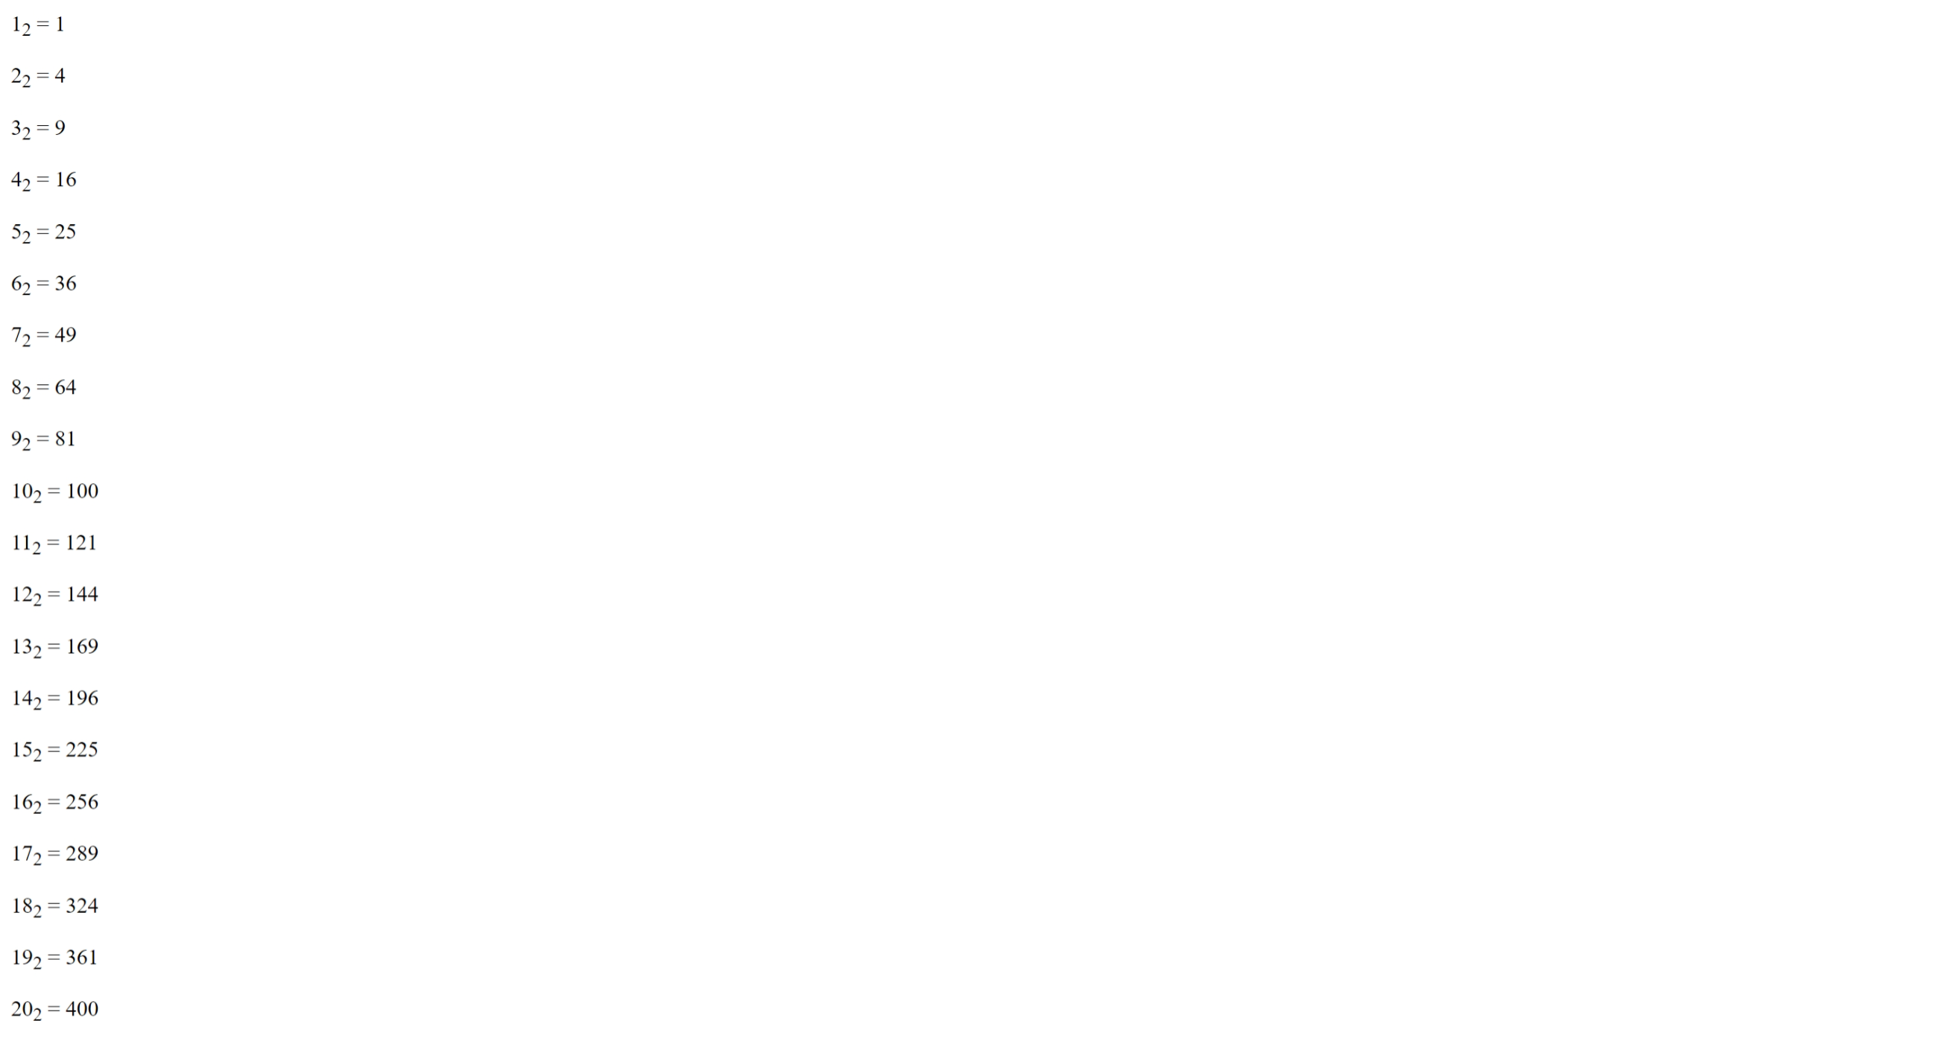

Q10) . write an html code to display an image with border of size with width 200 height 200 pixels , leaving Hspace and Vspace of your choice with image hanging in the right side on the screen.

<HTML>

<head>

<title>Image Display</title>

<style>

img {

border: 2px solid black;

width: 250px;

height: 250px;

display: block;

margin-left: auto;

margin-right: 0;

margin-top: 20px;

margin-bottom: 20px; }

</style>

</head>

<body>

<img src="C:\Users\Astitva Sharma\Downloads/buildings.jpg" alt="buildings" align="left">

</body>

</html>



Q11) Write a html code to create a web page with heading. the heading shall be displayed at the top-centre of the page and the image shall be at the centre , just below the heading .

<html>

<head>

<title>Centered Heading and Image</title>

<style>

body {

margin: 0;

font-family: Arial, sans-serif;

text-align: center;

justify-content: center;

align-items: center;

</style>

</head>

<body>

<h1>Eiffel Tower</h1>

<img src="C:\Users\Astitva Sharma\Downloads/paris.jpeg" alt="Eiffel tower" height="400" width="400">

</body>

</html>

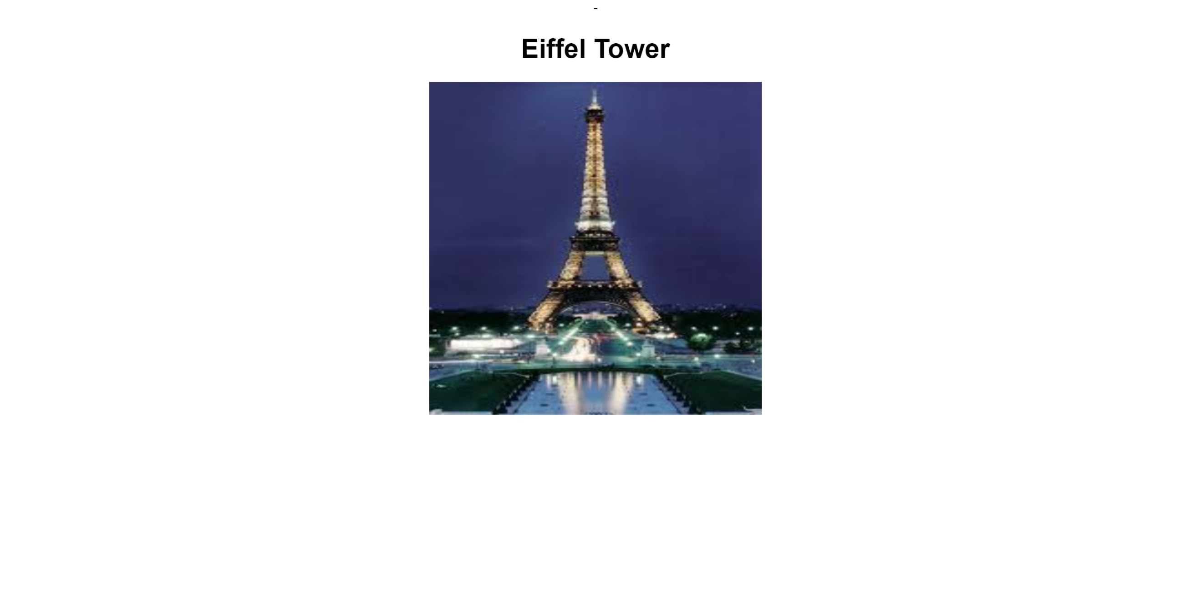  
Q12) Write HTML code using Multimedia tags.

<html>

<head>

<title> multimedia tags</title>

</head>

<body>

<h1> multimedia tags: </h1>

<h1>picture</h1>

<html>

<head>

<title> multimediatags</title>

</head>

<body>

<h1> multimediatags: </h1>

<h1>picture</h1>

<img src="C:\Users\Astitva Sharma\Downloads/indiagate.jpeg" alt="center">

<h1> audio</h1>

<audio src="C:\Users\Astitva Sharma\Downloads/ringtone.mp3" controls></audio>

<h1> video</h1>

<video src="C:\Users\Astitva Sharma\Downloads/230060_small.mp4" controls></video>

</body>

</html>

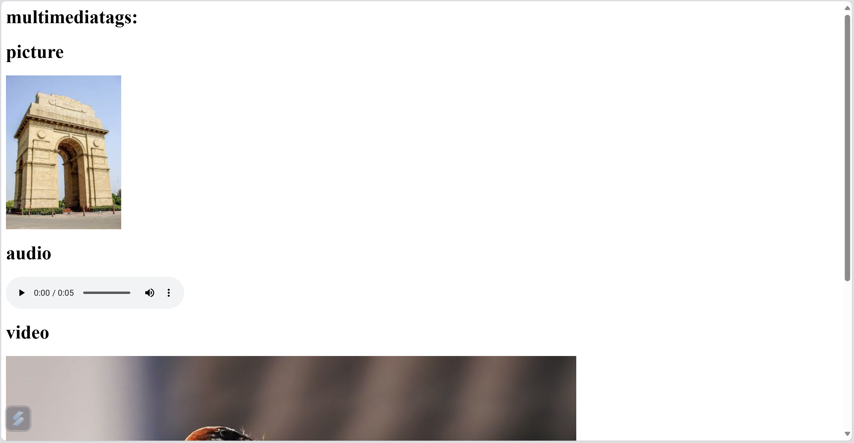

Q13) **:** **Create a Table using Rowspan and Colspan taking example of student Record?**

**<html>**

**<head>**

**<title> my world </title>**

**</head>**

**<body>**

**<h1> table </h1>**

**<table border="2">**

**<tr>**

**<th> name</td>**

**<th> age</td>**

**<td>jon</td>**

**<td rowspan="2">45</td>**

**</tr>**

**<tr>**

**<td>jerry</td>**

**</tr>**

**</table>**

**</body>**

**</html>**

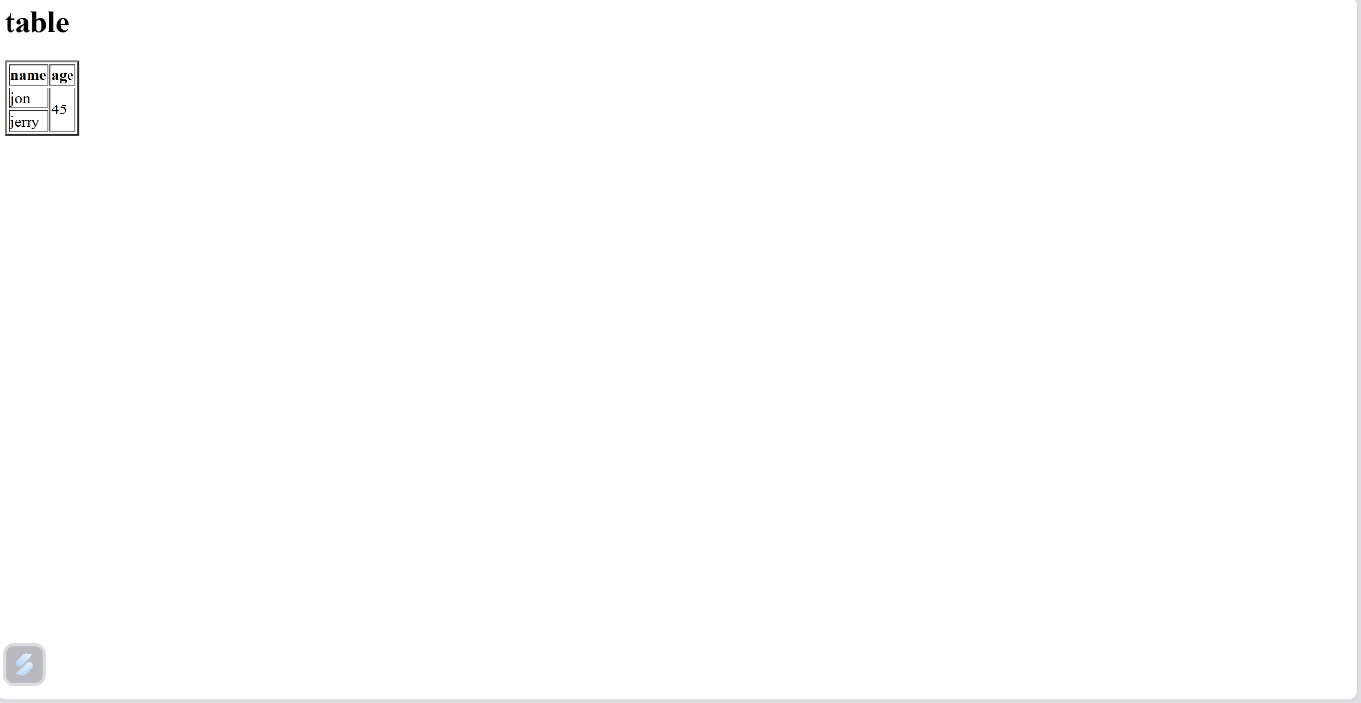

**<html>**

**<head>**

**<title> my world </title>**

**</head>**

**<body>**

**<h1> table </h1>**

**<table border="2">**

**<tr>**

**<th> name</td>**

**<th> age</td>**

**<th> id</th>**

**</tr>**

**<tr>**

**<td >jon</td>**

**<td colspan="2">23</td>**

**</tr>**

**<tr>**

**<td> jerry</td>**

**<td> 18</td>**

**<td> 2345 </td>**

**</tr>**

**</table>**

**</body>**

**</html>**

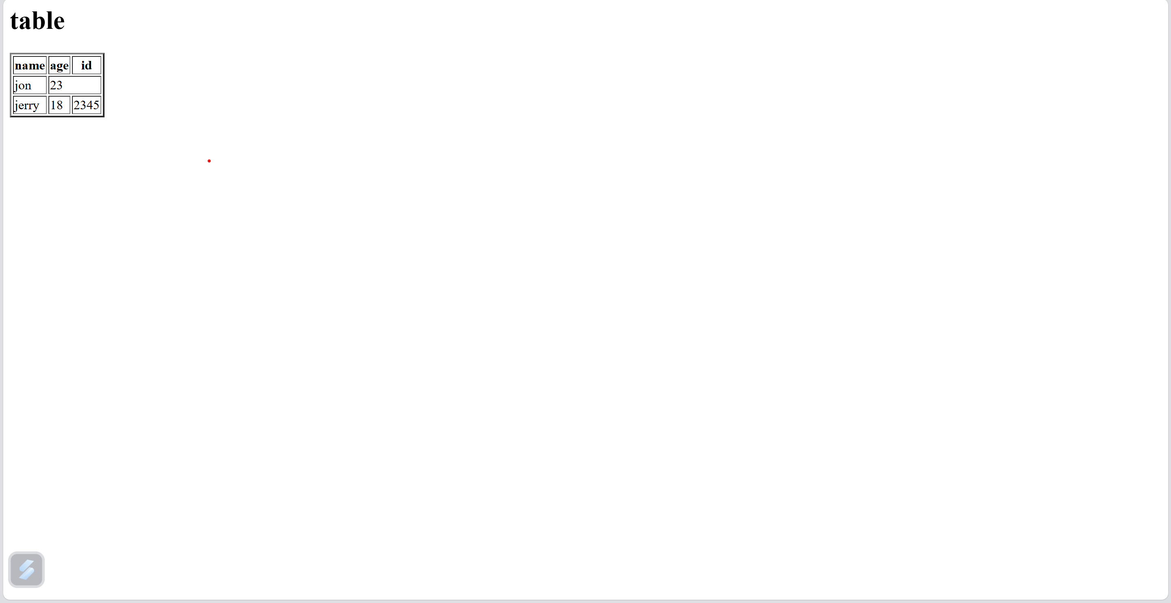

Q14) **Write HTML code using table tag <table> and cellpadding and cellspacing as its attributes.**

**<html>**

**<head>**

**<title>Student Table</title>**

**</head>**

**<body>**

**<table border="2" cellspacing="7" cellpadding="8">**

**<tr>**

**<th>Name</th>**

**<th>Age</th>**

**<th>Registration id</th>**

**<th>Qualification</th>**

**</tr>**

**<tr>**

**<td>Jon</td>**

**<td colspan="2">18</td>**

**<td rowspan="2">12th pass</td>**

**</tr>**

**<tr>**

**<td>Jerry</td>**

**<td>19</td>**

**<td>44</td>**

**</tr>**

**<tr>**

**<td>Jake</td>**

**<td>22</td>**

**<td>23</td>**

**<td>Graduate</td>**

**</tr>**

**<tr>**

**<td>Justin</td>**

**<td>20</td>**

**<td>33</td>**

**<td>12th pass</td>**

**</tr>**

**</table>**

**</body>**

**</html>**

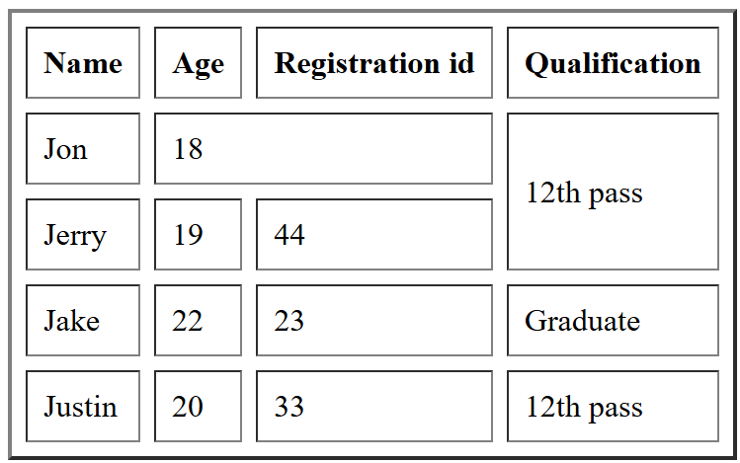

Q15) Create unordered, ordered and definition Lists taking example of your subjects in MCA IST, IInd and IIIrd Semester.

<html>

<head>

<title> Mca subjects</title>

</head>

<body>

<list>

<ul>

<h2>MCA 1st year subjects</h2>

<li>Computer Organization and Architecture</li>

<li>Computer Networks</li>

<li>Information Systems Analysis</li>

</ul>

<h2>Mca 2nd year subjects</h2>

<ol>

<li>Database Management System II</li>

<li>Operation Research and Optimisation Techniques</li>

<li>Environment and Ecology</li>

<li>Software Project Management lab</li>

<li>Graphics and Multimedia Lab</li>

<li>Advanced Database lab </li>

</ol>

<h2>Mca 3rd year subjects</h2>

<dl>

<dt>Advanced Database Management System</dt>

<dd>Focuses on advanced concepts in database design, including distributed databases, data warehousing, and database security.</dd>

<dt>Software Engineering</dt>

<dd>Covers the methodologies, tools, and techniques used in software development. Emphasizes the software development lifecycle, project management, and quality assurance.</dd>

<dt>Web Technologies</dt>

<dd>Data Structures and Algorithms</dd>

<dt>Operating Systems</dt>

<dd>Examines the fundamental concepts of operating systems, including process management, memory management, file systems, and system security.</dd>

</list>

</body>

</html>

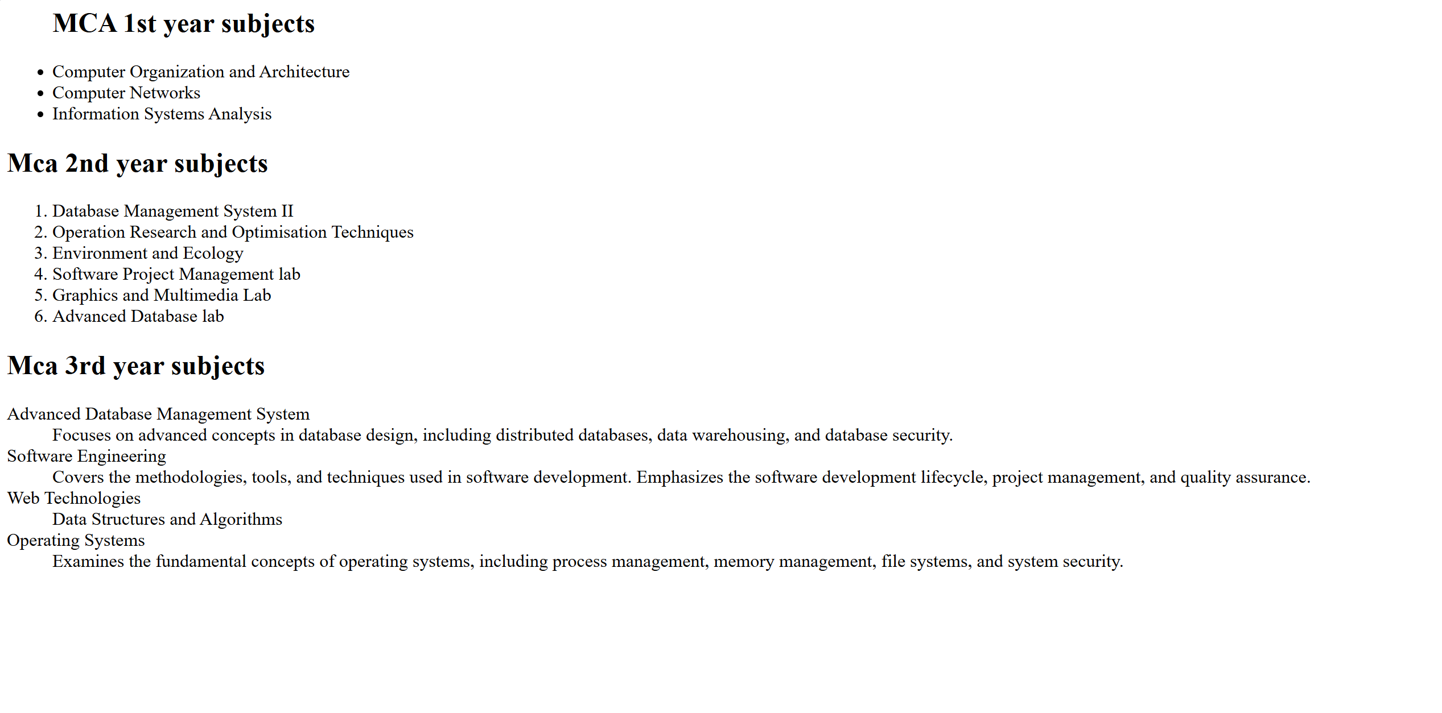

Q17) Write HTML code to design a form in HTML using controls and buttons such as Teaxtbox, Textarea, <HTML>

<HEAD>

<title>Form making</title>

</head>

<BODY>

<form>

Name <br>

<input type="textbox"/><br>

password<br>

<input type ="password" name="passwo"><br>

<label for="gen">Gender</label><br>

<input type="radio" name=rad/>Male

<input type="radio" name=rad/>female

<input type="radio" name=rad/>others<br>

Father's name <br>

<input type="textbox"><br>

Mother's name<br>

<input type="textbox"><br>

Email id <br>

<input type ="email" name=ema><br>

Phone number<br>

<input type="text" maxlength="10"><br>

Text area

<textarea cols"30" rows="20"></textarea> <br>

<button>Submit</button>

<input type ="file" name=ema><br>

Age<br>

<select id="age" name="ag">

<option value="18" id="age" name="Age">18</option>

<option value="19" id="age" name="Age">19</option>

<option value="20" id="age" name="Age">20</option><br><br>

</form>

</body>

</html>

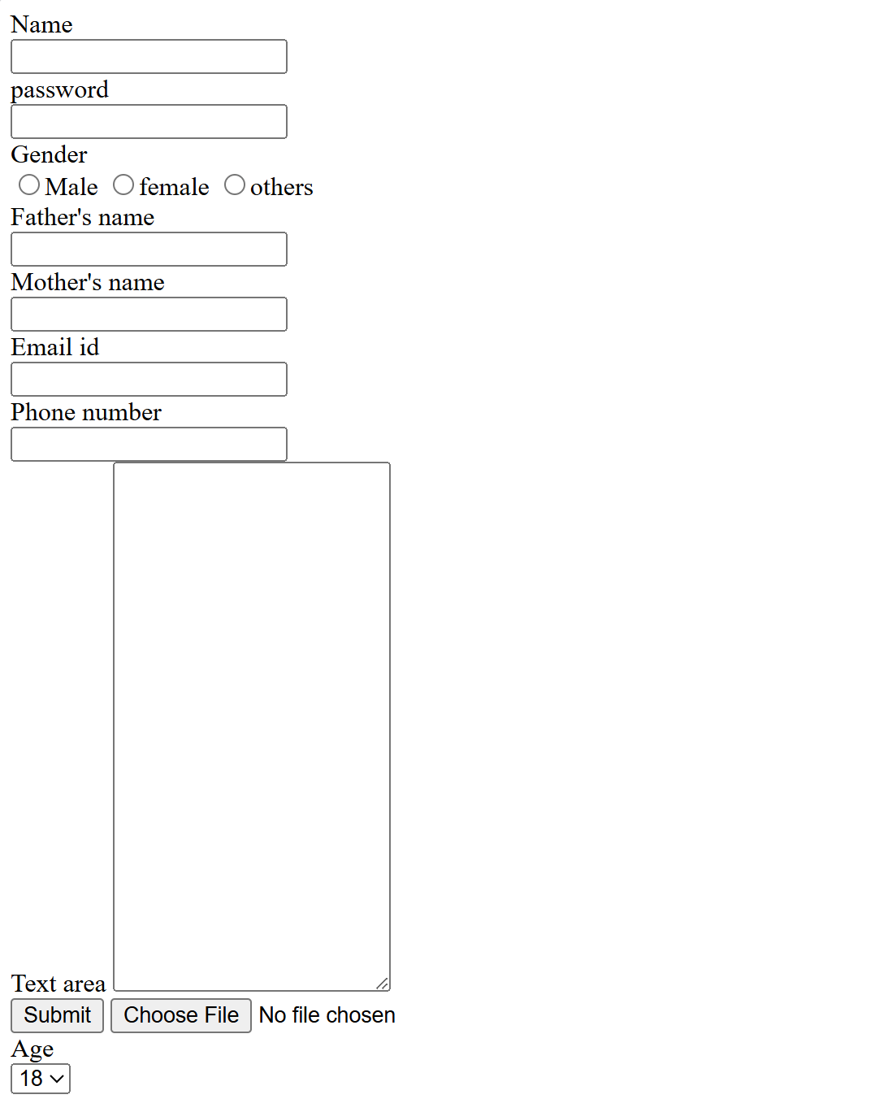

Q18) Write HTML code to design a Registration Form in HTML.

<html>

<head>

<title>Registration form for Hackathon</title>

</head>

<body>

<form>

<fieldset>

<legend>Hackathon Registration</legend>ss

Name<br>

<input type ="text"/><br>

Email id<br>

<input type="email"/><br>

Age<br>

<input type="radio" name="rad"/> 17-19

<input type="radio" name="rad"/> 19-21

<input type ="radio" name="rad"/>21-24<br>

Languages available<br>

<input type="checkbox" name="check"/>Html

<input type="checkbox" name="check"/>Css

<input type="checkbox" name="check"/>Java<br>

<button>Submit</button>

<button>Reset</button>

</fieldset>

</form>

</body>

</html>

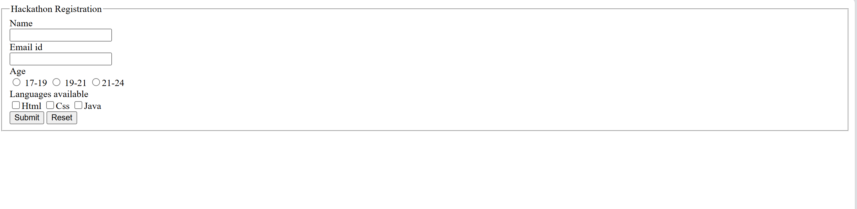

Q19) Write HTML code to design a student admission Form in HTML.

<html>

<head>

<title>College Registration form</title>

</head>

<h1>College Registration Form</h1>

<body>

<Form>

<fieldset>

Full name<br>

<input type="text"/><br>

Age<br>

<input type="radio" name="rad"/>17-19

<input type="radio" name="rad"/>19-21

<input type="radio" name="rad"/>21-24<br>

Gender<br>

<input type="radio" name="radi"/>Male

<input type="radio" name="radi"/>Female

<input type="radio" name="radi"/>Others<br>

Date of Birth:<br>

<input type="Date" name="dat"/><br>

Phone number<br>

<input type="text"/><br>

Father's Contact number<br>

<input type="text"/><br>

Mother's Contact number<br>

<input type="text"/><br>

Email id<br>

<input type ="email"/><br>

Address<br>

<input type="text"/><br>

Qualification<br>

<input type="radio" name="rad">12th pass

<input type="radio" name="rad">Graduation<br>

Cbse 12th Marksheet<br>

<input type="file"/><br>

Choose Course<br>

<input type="checkbox" name="check"/>BCA

<input type ="checkbox" name="check"/>B.Tech.

<input type ="checkbox" name="check"/>B.com

<input type ="checkbox" name="check"/>Bba<br>

<button>Submit</button>

<button>Reset</button>

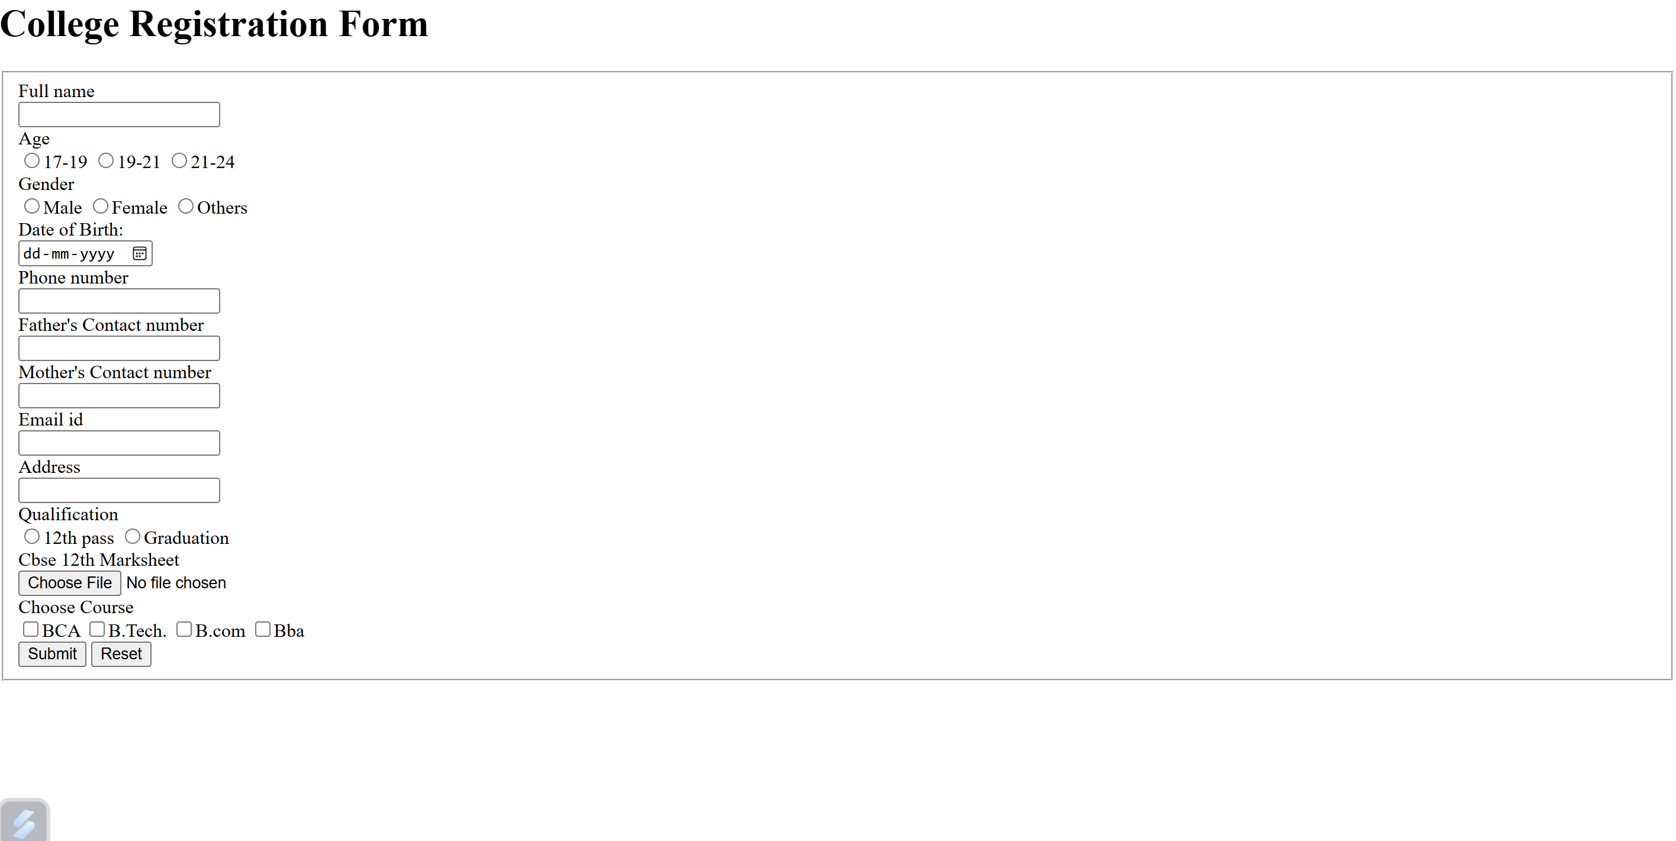

Q20) Create a proper home page of your own using any components and styles.

<html>

<head>

<style>

<html>

<head>

<style>

H1 {

text-align: left;

color: black;

}

p {

text-align: center;

color: purple;

}

#para1{ text-align: right;

color:brown;

}

.center{ text-align: center;

color: grey;

}

</style>

</head>

<body>

<h1> LINKEDIN </H1>

<p id ="para1">Connect to opportunity.</p>

<p class="center">Unlock your potential</p>

<p> Free trial for 3 months</p>

</body>

</html>

